Driver Drowsiness Detection System Based on Visual Features

Abstract— Nowadays, Driver drowsiness is one of the major cause for most of the accidents in the world. Detecting the driver eye tiredness is the easiest way for measuring the drowsiness of driver. The existing systems in the literature, are providing slightly less accurate results due to low clarity in images and videos, which may result due to variations in the camera positions. In order to solve this problem, a driver drowsiness detection system is proposed in this paper, which makes use of eye blink counts for detecting the drowsiness. Specifically, the proposed framework, continuously analyzes the eye movement of the driver and alerts the driver by activating the vibrator when he/she is drowsy. When the eyes are detected closed for too long time, a vibrator signal is generated to warn the driver. The experimental results of the proposed system, which is implemented on Open CV environment with a single camera view, illustrate the good performance of the system in terms of accurate drowsiness detection results and thereby reduces the road accidents.

Keywords— EAR ratio, Eye Detection, Blink

Count, Image processing

I. INTRODUCTION

The number of motor vehicles in developing countries has been gradually increased over the decade. Official investigation reports of traffic accidents point out that dangerous driving behavior, such as drunk and drowsy driving, account for a high proportion of accidents. Several further overview, many sleep-related vehicle accidents occur during the periods of around 2:006:00 A.M. and 14:0016:00 P.M, and it is often pointed out that night shifts make drivers particularly vulnerable . On average traffic, road accidents in the world claim 1.3 million lives and cause 50 million disabilities annually .

Driver drowsiness is a serious hazard and major concern, which is identified as a direct or contributing cause in most of the road accidents. Since drowsiness can seriously slow down the reaction time and subsequently decreases drivers awareness and judgment. The development of a driver monitoring system capable of producing warning to the driver upon detecting signs of drowsiness can prevent road accidents and thus save lives. From another prospective, image processing gained popularity in computer science engineering, selected fields which has impacted in multi dimensional way. If image processing technique are used for drowsiness detection, it can simultaneously reduce road accidents promise scheme which detect driver drowsiness with help of image processing such as eye blink count.

II. RELATED WORK

In 2007, Arimitsu et al. , developed the driving simulator with the seat belt motor retractor, which was used in a commercial vehicle, to provide the vibration stimulus to the drivers. The limitation of this paper was variation of the portions, which was stimulated by the seat belt. In 2008, Liang et al. , proposed a novel braincomputer interface (BCI) system that can acquire and analyze electroencephalogram (EEG) signals in real-time to monitor human physiological as well as cognitive states, and in turn, provide warning signals to the users when needed. The accuracy of the BCI system is slightly less when compared to the existing systems to detect the drowsiness. In 2010 Lin et al., proposed system consists of a wireless physiological signal-acquisition module and an embedded signal-processing module. In case if defects in the EEG monitor then the detection of drowsiness may decrease. In 2011, Kohji Murata et al. , developed a non invasively system to detect individuals driving under the influence of alcohol by measuring biological signals. The algorithm for the time series of the frequency fluctuations generated in this study has this potential. In 2012, Picot et al. , the features used by the EOG-based detector are voluntary restricted to the features that can be automatically extracted from a video analysis of the same accuracy. Despite its good performance, the method is slightly less accurate than some of the systems. In 2013, OyiniMbouna et al., proposed scheme uses visual features such as eye index (EI), pupil activity (PA), and HP to extract critical information on no alertness of a vehicle driver. If the pupil is red then it fails to detect the eye of the driver. In 2014, IsseyTakashashiet al., induced CRPS by paced breathing (PB) using pulse sound, which synchronized with heartbeats. For greater safety, methods need to be developed to physiologically overcome drowsiness. In 2016, J. Pilataxi et al. , presented a driving assistance system which detects drowsiness in the driver. If the robot fails the working will not be performed. Very recently in 2017, Qian et al. , proposed a method of Bayesian-copula discriminate classifier (BCDC) to detect individual drowsiness based on the physiological features extracted from electroencephalogram (EEG) signals. This study can be further generalized to other experimental environment to detect vigilance level or driver drowsiness. In 2017, CemBila et al., presented on an overview of research on ICT-based support and assistance services for the safety of future connected vehicles. It is hard to provide a systematic overview of open research challenges at a granular level.

Input image sequence
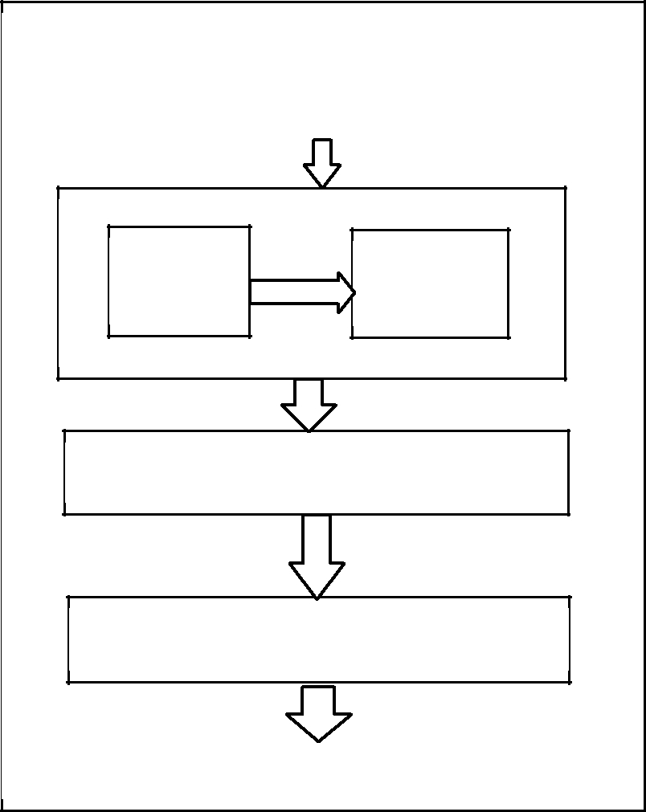

Face Eye

Detection Detection

Measure blink rate

Detection of Fatigue level

Output: Driver Status

Fig. 1. Block Diagram of Proposed Driver Drowsiness Detection

System.

To, summarize, existing system are providing slightly less accuracy results due to low clarity image and videos, which results for variation in the camera position. To overcome these problems the proposed paper introduces drowsiness detection which are shape predictor algorithm detects the eyes of a person, and also counts the eye blink of the driver to avoid the accidents.

III. PROPOSED FRAMEWORK

Fig.1 shows the block diagram of the proposed detection system. Precisely, the proposed system is to detect closed eyes to observe drivers fatigue and alert the driver with a buzzer and vibration on positive detection. During monitoring, the system is able to decide whether the eyes are open, closed or drowsy. When the eyes were detected closed for too long, a warning signal is issued. This was done by mounting a camera in front of the driver and continuously capturing its real-time video using Open CV in Raspberry Pi, previously. Driver drowsiness can be determined from several symptoms that manifest in drowsy drivers face. Through the analysis of the eye status, the system will be able to tell whether the driver is drowsy or not. Initially when the camera is in on state, video streams are continuously captured from the drivers face. To detect the eye blink, the current state of the eye is needed which is either open or closed. If the state of eyes changes from closed to open, it indicates an eye blinking. If the state of the eyes is in closed state for a certain amount of time then the person is detected as drowsy and shape predictor is used to predict the state of the drivers eye. If a drowsy driver is detected an buzzer sound and the vibration is raised, until the driver is alert.

Fig.2. depicts the experimental setup of proposed detection framework, in which different components of the system and

their respective connections are indicated. To evaluate the proposed method, Raspberry pi-B module 3 is used as a preprocessor, which processes the images. Raspberry pi has an SD card inserted into the slot on the board which acts as the hard drive for the Raspberry Pi. It is powered by USB and the video output can be hooked up to a traditional RCA TV set, a modern monitor, or even a TV using the HDMI port. The web camera is used to detect the eye of the driver, the data collected from the camera is sent to the Raspberry pi, after data processing, if the driver is drowsy then he/she will the alerted with vibrator which is placed under the driving seat.

IV. EXPERIMENTAL SETUP AND RESULTS

- Eye detection

The aim is to identify the eye from the face of a driver

using shape predictor. The eye detector was loaded with the Harr detectors which can detect eyes describing the contrast taking measurement of the distance between eye area and the ear area it will recognized area as eye in the face.

B. Blink count

High eye blinking rate indicates the drowsiness level of the driver. Generally, for adults there is an interval of 2-10 seconds between each eye blink. After the eye area detected the camera will capture the eye of the driver it will count the eye blink. The eye detection algorithm only detects the eyes if they were opened, this will helps in detecting the drivers drowsiness. Using this information, it is possible to assess if the driver has his/her eyes closed and count the number of time the user blinks. One among two eyes is enough to detect the eye blink rate. The blink rate which is lasting 3 or 4 second was assumed as fatigue condition.

represents the snapshot of the input image, in which driver’s eyes are detected as open. In general,blink rate for normal person is 2-10seconds and around 10 blinks per minute, is considered as normal eye conditions. Based on these factors eye open is detected and shown in the Fig.3 input image.

Its represent the snapshot of the input image in which drivers eyes are detected as closed. In general, eye blink count reduces, then eye close is detected and shown as Fig.4.

Fig.5. represents the snapshot of the input image, in which drivers eyes are detected as drowsy. Generally, when blink rate of a reduces below 10 blinks per minute, is considered as abnormal eye conditions. Based on these factors, when eye is closed for too long the drowsy is detected as shown in Fig.5.

Fig.6. represent the snapshot of Facial Landmark of the eye where each eye is represented by 6 (x, y)-coordinates, starting at the left-corner of the eye, and then working clockwise around the remainder of the region.

EAR = ||(p2 − p6) -||(p3 − p5)/(2||p1 − p4||) (1)

The Eye Aspect Ratio (EAR) between height and width of the eye is computed where p1 to p6 are the 2D landmark locations, depicted in Figure6. The EAR is mostly constant when an eye is open and is getting close to zero while closing an eye. It is partially person and head pose insensitive. Aspect ratio of the open eye has a small variance among individuals and it is fully invariant to a uniform scaling of the image and in-plane rotation of the face. Since eye blinking is performed by both eyes synchronously, the EAR of both eyes is averaged.

EXPERIMENTAL RESULTS

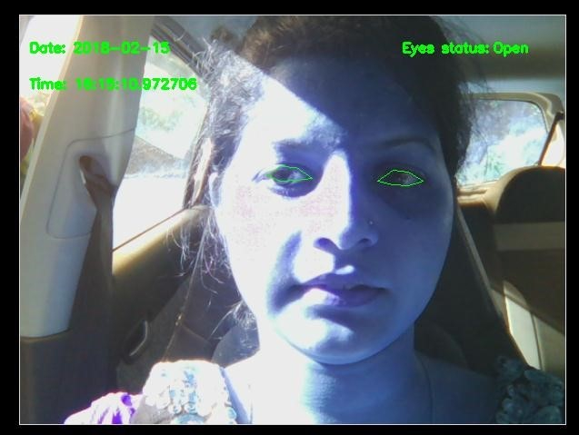

V. CONCLUSION

This paper introduces a drowsiness detection framework based on shape predictor algorithm, that detects the eyes, and also counts the eye blink rate followed by drowsiness detection at real time. In the proposed system, the details about the eye status is obtained through image processing algorithms, which offer a non-invasive approach to detect drowsiness without any annoyance and interference. In future, the detection of yawning of the driver can be also be implemented using same frame work for detecting further details about the drowsiness of driver.
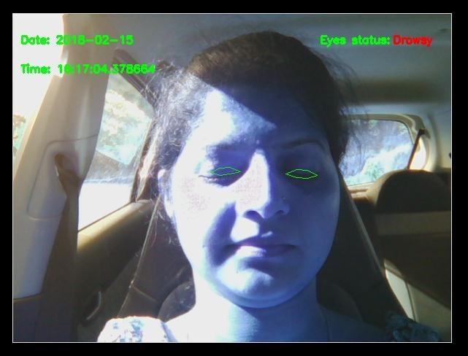

Fig. 3: Snapshot of input image, in which open eye is detected
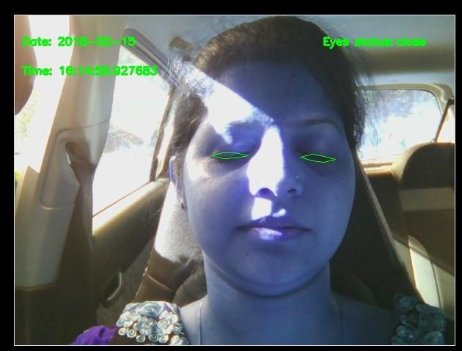

Fig. 4: Snapshot of input image, in which a closed eye is detected

Fig. 5: Snapshot of input image, in which drowsiness is detected

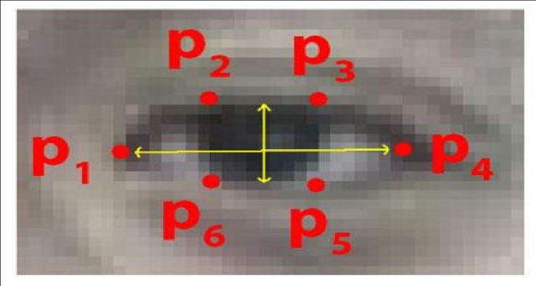

Fig. 6: Snapshot showing Facial Landmark Points of the Eye

REFERENCES

- Y Saito, M Itoh, and T Inagaki, Driver Assistance System With a Dual Control Scheme: Effectiveness of Identifying Driver Drowsiness and Preventing Lane Departure Accidents, in IEEE Transactions on human-machine systems, vol. 46, no. 5, page no 660-672, 2016.

- K T Chui, K F Tsang, H R Chi , B W K Ling , and C Kit Wu, An Accurate ECG-Based Transportation Safety Drowsiness Detection Scheme, in IEEE Transactions on industrial informatics, vol. 12, no. 4, page no 1438-1443, 2016.

- S Arimitsu, K Sasaki, H Hosaka, M Itoh, K Ishida, and Akiko Ito, Seat Belt Vibration as a Stimulating Device for Awakening Drivers, in

IEEE/ASME Transactions on mechatronics vol. 12, issue 5,page no 511-
519 ,2007.

- C Lin, Fellow, Y Chen, T Huang, T Chiu, Li-Wei Ko ,in Sheng-Fu Liang, H Hsieh, S Hsu, and Jeng-Ren Duann, development of wireless brain computer interface with embedded multitask scheduling and its application on real-time drivers drowsiness detection and warning in IEEE Transactions on biomedical engineering vol. 55,issue 5,page no 1582-1592, 2008.

[ 5] C Lin, Fellow, C Chang, B Lin, S Hung, C Chao, and I Wang, A Real-Time Wireless BrainComputer Interface System for Drowsiness Detection in IEEE Transactions on biomedical circuits and systems, vol. 4, no. 4,page no 214-221, 2010

  - K Murata, E Fujita, S Kojima, S Maeda, Y Ogura, T Kamei, T Tsuji, S kaneko, M yoshizumi, and N Suzuki noninvasive biological sensor system for detection of drunk driving in IEEE Transactions on information technology in biomedicine 15, no. 1, page no 19-25, 2011.

- A Picot, S Charbonnier, and A Caplier , On-Line Detection of Drowsiness Using Brain and Visual Information, in IEEE Transactions on systems, man, and cyberneticspart a: systems and humans vol. 42, no. 3, page no 764-775, 2012.

[ 8] R Oyini Mbouna, Seong G. Kong, and M Chun, Visual Analysis of Eye State and Head Pose for Driver Alertness Monitoring, in IEEE Transactions on intelligent transportation systems, vol. 14, no. 3, page no 1462-1469, 2013.

[ 9] I Takahashi, T Takaishi, and K Yokoyama, Overcoming Drowsiness by Inducing Cardiorespiratory Phase Synchronization, in IEEE Transactions on intelligent transportation systems vol. 15, no. 3, page no 982-991, 2014.

[10] J. Pilataxi, W. Vian and D. Chavez, Design and Implementation of a Driving Assistance System in a Car-like Robot When Fatigue in the User is Detected, in IEEE Latin America transactions vol. 14, no. 2, page no 457-463, 2016.

[11] D Qian, B Wang, X Qing, T Zhang, Y Zhang, X Wang, and M Nakamura, Drowsiness Detection by Bayesian-Copula Discriminant Classifier Based on EEG Signals During Daytime Short Nap in IEEE Transactions on biomedical engineering vol. 64, no. 4, page no 743-754, 2017.

- Cem Bila, Fikret Sivrikaya, M A. Khan and Sahin Albayrak, Vehicles of the Future: A Survey of Research on Safety Issues, in IEEE Transactions on intelligent transportation systems vol. 18, no. 5, page no 1046-1065, 2017.

